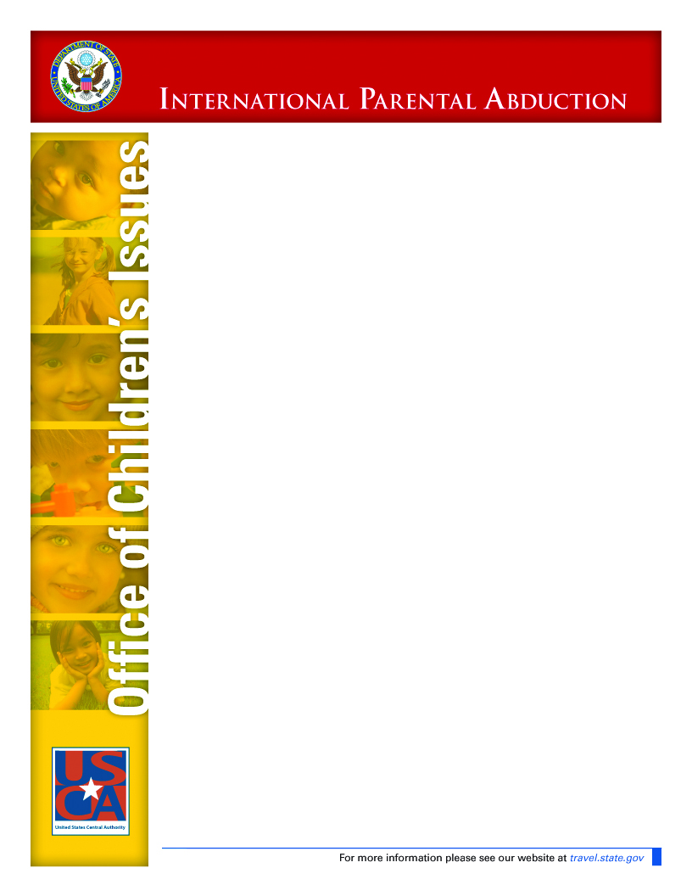
U.S. Department of State
Attorney Network

THE OFFICE OF CHILDREN’S ISSUES in the U. S. Department of State serves as the U.S. Central Authority for the Hague Convention on the Civil Aspects of International Child Abduction (“Convention”). The Convention provides a civil mechanism for securing the prompt return of wrongfully removed and wrongfully retained children to their countries of habitual residence. It also addresses access rights. Federal implementing legislation, the International Child Abduction Remedies Act (“ICARA”), sets forth procedures for litigating Convention cases in U.S. courts. The Convention is currently in force between the United States and 68 treaty partners, and the number continues to grow.

The U.S. Central Authority has numerous functions, including facilitating the institution of judicial proceedings in the United States “with a view to obtaining the return of the child and, in a proper case, to make arrangements for organizing or securing the effective exercise of rights of access.” Article 7(f). A network of volunteer attorneys was developed to fulfill this responsibility. Until April 2008, the National Center for Missing & Exploited Children ran the International Child Abduction Attorney Network (“ICAAN”) for the Department of State. However, in April of 2008, the U.S. Central Authority assumed primary responsibility for all “incoming” casework, including operation of the attorney network. Attorneys who had signed up for ICAAN were invited to participate in the U.S. Central Authority’s Attorney Network, and nearly all did. To keep pace with the caseload, the Attorney Network is seeking new members to join its ranks.

Lawyers that join the Attorney Network are asked to consider taking Hague Convention return and access cases on a pro bono or reduced fee basis. There is never an obligation to take a case. Applicants are informed that they will be expected to contribute toward court fees and related expenses. Legal fees and expenses may be recoverable under the Convention (Article 26) and the implementing statute (42 U.S.C. 11607), and under state law when state law remedies are pursued (e.g., UCCJEA). Lawyers in the Attorney Network also are included on ‘full fee’ lists requested by applicants that can afford to pay attorney fees. When a lawyer is retained by an applicant-parent, the attorney-client relationship is strictly private. Applicants are informed that the lawyer neither works for nor represents the U.S. government.

Lawyers with and without Hague experience are welcome to join the Attorney Network. Family lawyers are naturals: They have the background to assist parents using the Hague Convention or state law remedies. (The Convention is a non-exclusive remedy.) But family law experience is not a prerequisite. In fact, many large corporate law firms take Hague Convention cases pro bono and report great satisfaction with the work. They often file Convention cases in federal courts, which have concurrent jurisdiction with state courts under ICARA.

For those litigating Convention cases, a wealth of experience is available on our website. Experienced attorney mentors are available upon request. Additionally, a language line translation service is available through the Department at no cost to attorneys to facilitate telephone communications.

Thank you for your interest in joining the Attorney Network. Network attorneys provide legal representation to parents involved in international parental child abduction cases.
JOIN OUR NETWORK

For more information about the Attorney Network, contact Legal Assistance Coordinators Beth Cooper and Patricia Hoff at cooperbh@state.gov, hoffpm@state.gov, 202-736-9096, and view the website, www.travel.state.gov/abduction.

Please e-mail this form to HagueConventionAttorneyNetwork@state.gov or fax it to 202-736-9132.

Name _______________________________________________________________

Firm ________________________________________________________________

Address _____________________________________________________________

City and State _______________________________________ Zip ______________

Phone _____________________________ Fax ______________________________

E-mail ____________________________ Website ___________________________

States in which you are licensed, active and in good standing (Please inform us if your license status changes)

___________________________________________________________________
Courts in which you are admitted

_____________________________________________________________________
Languages Spoken

_____________________________________________________________________
Type of practice: (litigation, family law, international, mediation, other)

_____________________________________________________________________

Hague Litigating Experience Yes ______ No ______

Offer Pro Bono Legal Services Yes ______ No ______

Offer Reduced Fee Legal Services Yes ______ No ______

Please contact me about incoming non-Hague Convention cases ____ yes ____ no

